Last Update: 8/5/25 - 1

**SOCIAL THEORY &**

**DESIGN THINKING**

(2410302)

Politics & Global Studies (PGS)

1st Semester 2025 (1/2024-26)

Tuesday: 1–4 p.m.

Building POL3, Room M08

**Group Exercise Warm-Up**: Week 1 (8/5/25): The LEGO® Serious Play® (LSP) and the STEAM (Science Technology Engineering Arts and Mathematics) Creative Toys—The Magnetic Tiles

The LEGO® Serious Play® (LSP) Method:

Developed by the LEGO Group in the 1990s, the LEGO® Serious Play® (LSP) has recently been used to stimulate engagement, conversation, creative thinking, problem solving, and strategic planning in business and public organizations around the world. There are basically FIVE steps in conducting this play.

1) Set the topic(s) and question(s) relevant to the problem(s) that you want the players to engage with.

2) Build the model (or structure) pertaining to the problem(s) assigned. 3) Demonstrate the model (or structure) being built using storytelling techniques to explain the model to others.

4) Share your thoughts and reflections about the model (or structure) built with others. 5) Conclude what you have learned from this play with others.

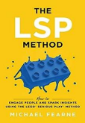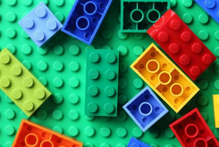

Last Update: 8/5/25 - 2

The STEAM (Science Technology Engineering Arts and Mathematics) Creative Toys—The Magnetic Tiles:

Utilizing the LSP method for this year’s course, we, however, switch to a new set of instructional media, the magnetic tiles, which can be classified under a subcategory of the newly designed and launched category of creative toys called STEAM (Science Technology Engineering Arts and Mathematics) from Mideer Thailand (see Illustration #1 below).1

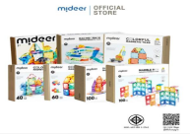

Illustration #1: The variety of the magnetic tiles, a category of the creative toys called STEAM (Science Technology Engineering Arts and Mathematics) from Mideer Thailand

The magnetic tiles, despite vary by the numbers of pieces contained in the merchandises, can be further categorized into two types: the generic, classic sets and the specific model sets, according to what specific models the pieces in the packages can possibly be assembled into. On the one hand, the generic, classic sets offer high creative flexibility and discretion, by featuring the assorted pieces of different shapes and forms in the merchandises, that allow the users/players to design and assemble various models (see Illustration #2 below). On the other hand, the specific model sets are pre-designed to enable the users/players to build only certain models using the specified pieces in the merchandises, for example, safaris, dinosaur parks, metropolitans, castles, houses, buildings, space stations, roads, racing tracks, etc. One of the most popular specific model sets is the Marble Run, a rolling ball sculpture that is also a form of kinetic art (see Illustration #3 below).

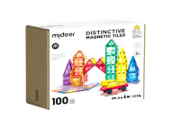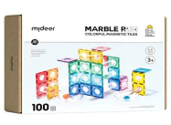

Illustration #2: The generic, classic 100-pieces distinctive magnetic-tiles set from Mideer Thailand Illustration #3: The 100-pieces specific model set: The Marble Run from Mideer Thailand

1 The URL for Mideer Thailand:

https://www.mideerthailand.com/?srsltid=AfmBOorYBL7vvPkno2X_87BsLPOyT_EhrgG3c5_bhamYXiDc8En5Bcn

Last Update: 8/5/25 - 3

Task: Please get into the groups of 4-5 members for the total of 12 groups. Your group members will likely stay the same for the entire semester for the other group exercises throughout the course. Then, follow the instruction below. You have the total of 1.30 hrs. to finish the entire process through the five steps of the LSP method specified above. After that, we will go around the room and chit-chat with all groups. It’s an ice-breaking session for us to get to know each other and for you all to reflect on your teams’ experiences at the end of the course. *Be relaxed and let your imagination run free!*

***

**Design for Mobility and Dystopia Challenges**

Assignment 1: Design for Mobility (To Be Completed in Class on Week 1: 8/5/25)

Task: In a world increasingly connected through daily crossings of borders, transportation of resources, and the spread of ideas and knowledge, mobility has become a pressing issue. Using the Mideer Distinctive Magnetic-Tiles: The 100 Pieces Set provided, design and construct a vehicle or transport-related object. Your design must address one of the following goals (please choosing only one):

• Increase accessibility for people with disabilities

• Reduce environmental impact

• Solve a specific mobility issue in your community (e.g., traffic, last-mile transport) • Enable mobility in a difficult environment (e.g., desert, flood zones, war zones)

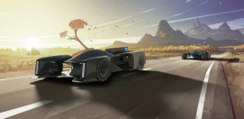

Your group must:

1. Collaborate to ideate, sketch, and build a prototype using the tiles. 2. Name your design and describe its function, users, and impact in a short (2-minute) group presentation.

3. Reflect briefly (in writing) on how your design reflects social needs and how design choices were made.

Last Update: 8/5/25 - 4

Assignment 2: Dystopia Design Challenge (To Be Completed as Your Homework before Week 3: 8/19/25)

Task: Imagine your group is living in a dystopian future where society has drastically changed (due to climate collapse, authoritarian rule, extreme inequality, AI takeover, etc.).

Design a sociotechnical structure or system using the Mideer Magnetic-Tiles: The Marble Run Set that helps people survive or resist within this dystopia.

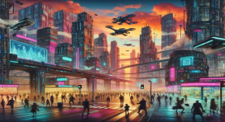

Your group must:

1. Define your dystopian world: What happened? Who has power? What are the living conditions? (Write a short paragraph and put it in your group portfolio; see below.) 2. Build a prototype of sociotechnical structure or system that helps with survival, rebellion, communication, or adaptation.

3. Take some digital photos of your design. Present your design by writing short paragraphs and put them in your group portfolio (see below), explaining: o The context of the dystopia

o The purpose and function of the design

o Ethical questions or trade-offs the design raises

4. Reflect briefly (in writing) on how design can both oppress or empower in times of crisis.

***

**Homework**: Week 2 (8/12/25): Individual and Group’s Free Writing Exercise

For each group’s member, please write (either handwriting or typewriting) only 1-2 pages *introducing yourself to us*. This introduction should at least include your biographical history such as what school you went to, what would be your future career, and why you want to come to pursue a degree with PGS, etc. An illustration in terms of your photo will be highly appreciated in order for us to remember you throughout the course.

Then, please assemble all of your group members’ self-introduction into one group portfolio. The portfolio should include your team’s reflection of the dystopia design challenge (see above).

Last Update: 8/5/25 - 5

Even though you will have one week off because Week 2’s meeting is a national holiday (Mother’s Day; Tuesday, 8/12/25), we suggest that you spend only an hour or two on this exercise, as your group members get together to assemble everything into a group portfolio. Submit a PDF digital copy by uploading it into Week 1’s folder in this year’s course Google Drive before the next two weeks’ meeting: Week 3: 8/19/25.

Nice to Meet You All and

Thank You for Your Cooperation,

You Instructor and TA